Handout 3: Diagram with Equipment and Inserted Steps¹⁰³
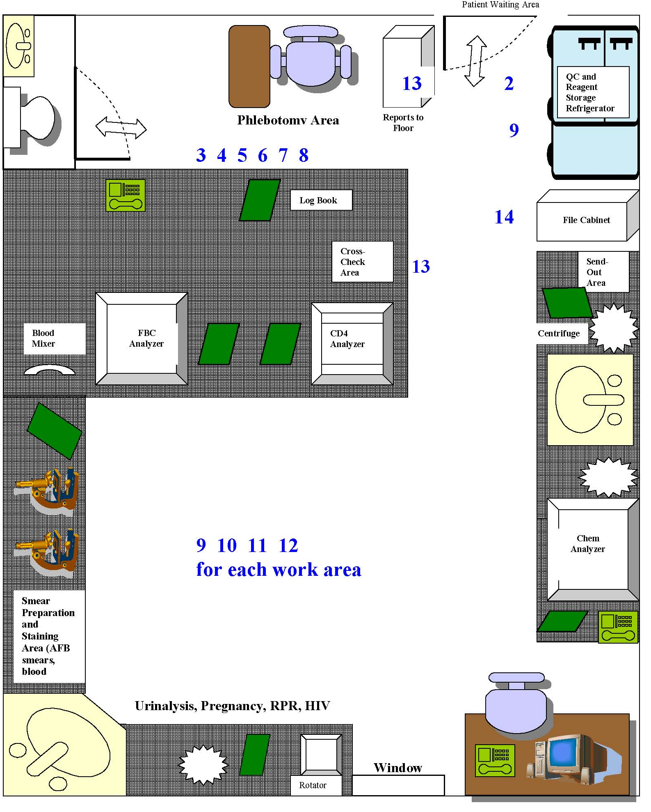
Window

